**Appendix IV : Intervention 2 – Test**

**Exercise 1:** On which side of the river was the rowboat? (left/right)

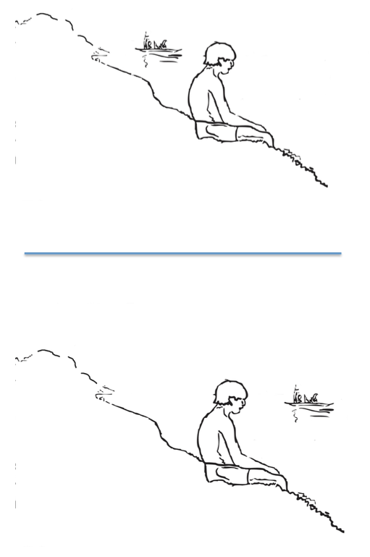

**Exercise 2:** Where was the dog? (up/down)

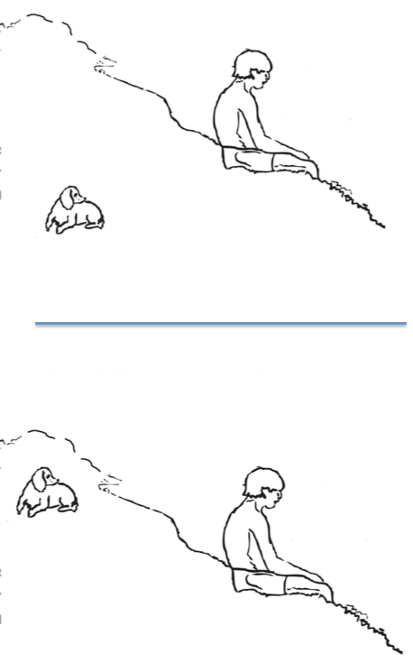

**Exercise 3:** How many kids were in the water?

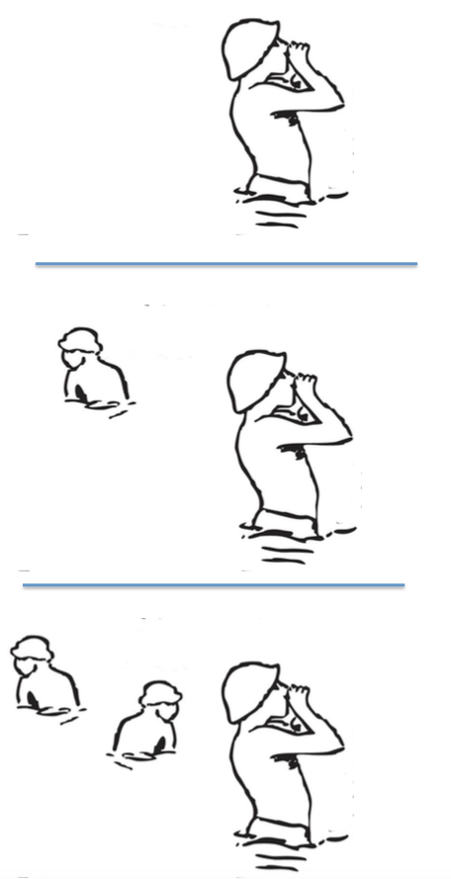

**Exercise 4:** Which of these hats was not in the painting?

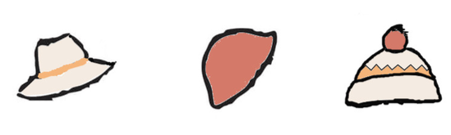

**Exercise 5:** Which color were the sails of the boats?

